Name_____________________________________________
Kamrass; English 10
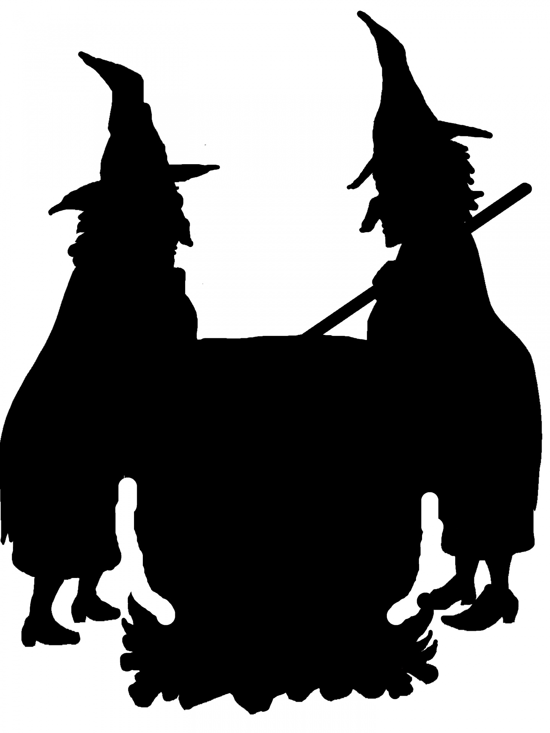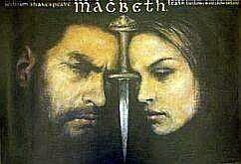

William Shakespeare’s
Macbeth
Background Information –Fill in the blanks.

The Play:
- In 1603, __________________ became the first Scottish king of England and a patron of Shakespeare’s theater company. In honor of King ____________________, the King’s Men staged Shakespeare’s Scottish play Macbeth in 1606.
- __________________ was a real Scottish king from 1040 to 1057, but Shakespeare changed his story significantly (he had a legitimate claim to the throne). Macbeth in this drama is wholly fictional.
- Some see this play as a tribute to _____________________ in another way: Banquo, a noble character in the play, was the king’s ancestor and the founder of his family line. (There are some who contend, however, that Banquo existed only in legend.)
  - The play’s inclusion of Banquo, may have helped support his right to the throne. Since Queen Elizabeth I did not have any children, she chose James to be her successor. This choice, as opposed to succession through direct lineage, may have made people question the legitimacy of __________________. The play clearly establishes that Banquo, and his descendants are rightful heirs.
- Even the inclusion of witches complimented __________________, who prided himself on his expert knowledge of witches and who wrote a treatise about them called Demonology in 1597.
- Though some educated people did not believe in witches, most among Shakespeare’s audiences took them seriously, making this play even more frightening for them. The three witches are also called the “Weird Sisters,” the word “weird” referring not to their appearance but to the original meaning of the word, “having the power to control fate.”
- The play was probably written in 1606 and may relate to the __________________ of 1605(there were plans to blow up the two Houses of Parliament and kill __________________ to replace him with a Catholic monarch). After the plot was discovered, these revolutionaries were brutally executed. Macbeth is about treason—killing a rightful king—and the consequences thereafter.
A Study Guide for Act I
Directions: Answer each question in complete sentences. When a “Q” appears next to a question, be sure to include a quote as part of your answer—explain thoroughly with context too.

Scene 1:

- In this brief scene we meet the three witches. What do we learn from the few things that they say?

- Q Define paradox and identify the famous paradoxical statement in this scene:

Scene 2:

- Who is Duncan and what does he want to know?

- Who is Malcom?

- Who is the traitor mentioned?

- Macbeth defeats this traitor: (Q) describe what he does to him.

- How is Macbeth related to the king?

- What is the name of the Scottish general who fights by Macbeth’s side?

- Who is Ross and what news does he bring? (Let’s talk about Ross and other noblemen in the play.)

- What will happen to the second Scottish traitor that they mention and who will get his title?

- Based on the report of others, how would you describe Macbeth up to this point (characterization)?

Scene 3:

- Do you sleep well? How do you feel when you’re sleep-deprived? What does this have to do with the witches at the start of this scene?

- In line 40, notice the reference to foul and fair again. How can the day seem “so foul and fair” to Macbeth?

- What three titles do the witches use to address Macbeth? Which titles are really his?

- Contrast Banquo’s behavior toward the witches to Macbeth’s:

- Q What prediction do the witches make for Banquo upon his request?

- What news do Ross and Angus bring to Macbeth?

- Interpret the following words from Banquo to Macbeth: “And Oftentimes, to win us to our harm,/ The instruments of darkness tell us truths,/ Win us with honest trifles, to betray’s/ In deepest consequence” (I, iii, 143-146).

- What does Macbeth begin to think about, and how does it make him feel?

- What does Macbeth mean when he says, “If chance will have me King, why, / chance may crown me, / Without my stir”?

Scene 4:

- King Duncan is with Malcolm and Donalbain. Who is Donalbain?

- What does King Duncan mean when he says (about the traitorous thane of Cawdor), “There’s no art / To find the mind’s construction in the face” (I, iv, 13-14)? Also: What might this foreshadow?

- How does the king speak to Macbeth and Banquo when they arrive at his castle?

- What announcement does King Duncan make regarding his son Malcolm and what is Macbeth’s reaction?

- What is the next honor that Duncan heaps on Macbeth?

Scene 5:

- Define soliloquy:

- In Lady Macbeth’s first soliloquy, how does she describe her husband? Does his character please her? Why or why not? Define Irony of Situation and discuss why her reaction is ironic:

- Lady Macbeth calls on the spirits of evil to “unsex her.” What does she mean? What does she want?

- What advice does Lady Macbeth give to her husband at the end of the scene?

- How would you describe Lady Macbeth so far?

Scene 6:

- How would you describe King Duncan based on this scene and his dialogue in the scenes before it?

Scene 7:

- In Macbeth’s first soliloquy, what does he say are the many reasons why he should not kill King Duncan? What is the only reason why he should?
Reasons not to kill the king Reason to kill the king

- What tactics does Lady Macbeth use to try to convince her husband to stick to their plan?

- What does Macbeth decide to do? What does he say about his wife’s personality?

